**WPS Office Suite Project**

Time to combine everything you have learned. You will be presenting the information you found on Friday in the form of a Presentation.

**Writer**

You will use Writer to create a Survey. The survey can ask any students anything about the school. Example. (Uniform, food, dorms, relationships, classrooms. Classes, University Focus.)

The survey must have 4 different types of questions.

* Multiple choice
* True False
* Short Answer
* Scale from 1-10

Checklist:

Title: largest font, underlined, and centered (3)

Questions: in a numbered listed, medium font, at least 2 of each type (3)

Multiple choice options should have a lettered list (A, B, C, D) (2)

Spacing: 1.5 (1)

Header: Your name and block, smallest font, right aligned (3)

**Total: 12 marks**

**Spreadsheets**

Once you’ve collected the data, enter the data into Spreadsheets and create a chart to represent your information for each question. (Note: You CANNOT make a chart for the short answer questions, but it is expected that they are in your presentation)

Checklist:

Creates at least 6 charts (3, 0.5/chart)

All information is on the spreadsheet and is organized. (2)

Students used the average formula at least once (1)

**Total: 6 marks**

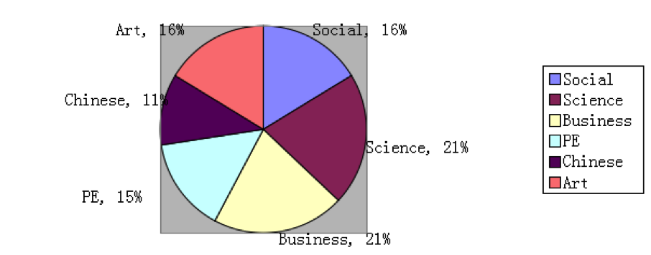

**Presentations**

* Finally, you will present your questions from the survey and results in a presentation to everyone in the class.
* You must use this checklist as well as the presentation rubric.
* Here is an example made by students.

Checklist:

All questions from the survey and charts (4)

Explanation of the demographic (1)

Explanation of what they have learned from the results (2)

**Total: 7 marks + Presentation rubric**



 